Digital Logic Lab 8 Report

Digital Logic 2116L

3/27/2018

Featheringill 210

Suyi Diao, Bryce

1. Introduction:

The basic concepts we learned for this lab how to use state machine and flip flop to build a intricate vending machine.

1. Design Requirements:

We need to build the circuit from prelab of the lab into the mother board, a vending machine that kept adding different types of coins based on input. When input reaches 30, the coin number goes to 0 and a led red light should be on.

1. Diagrams

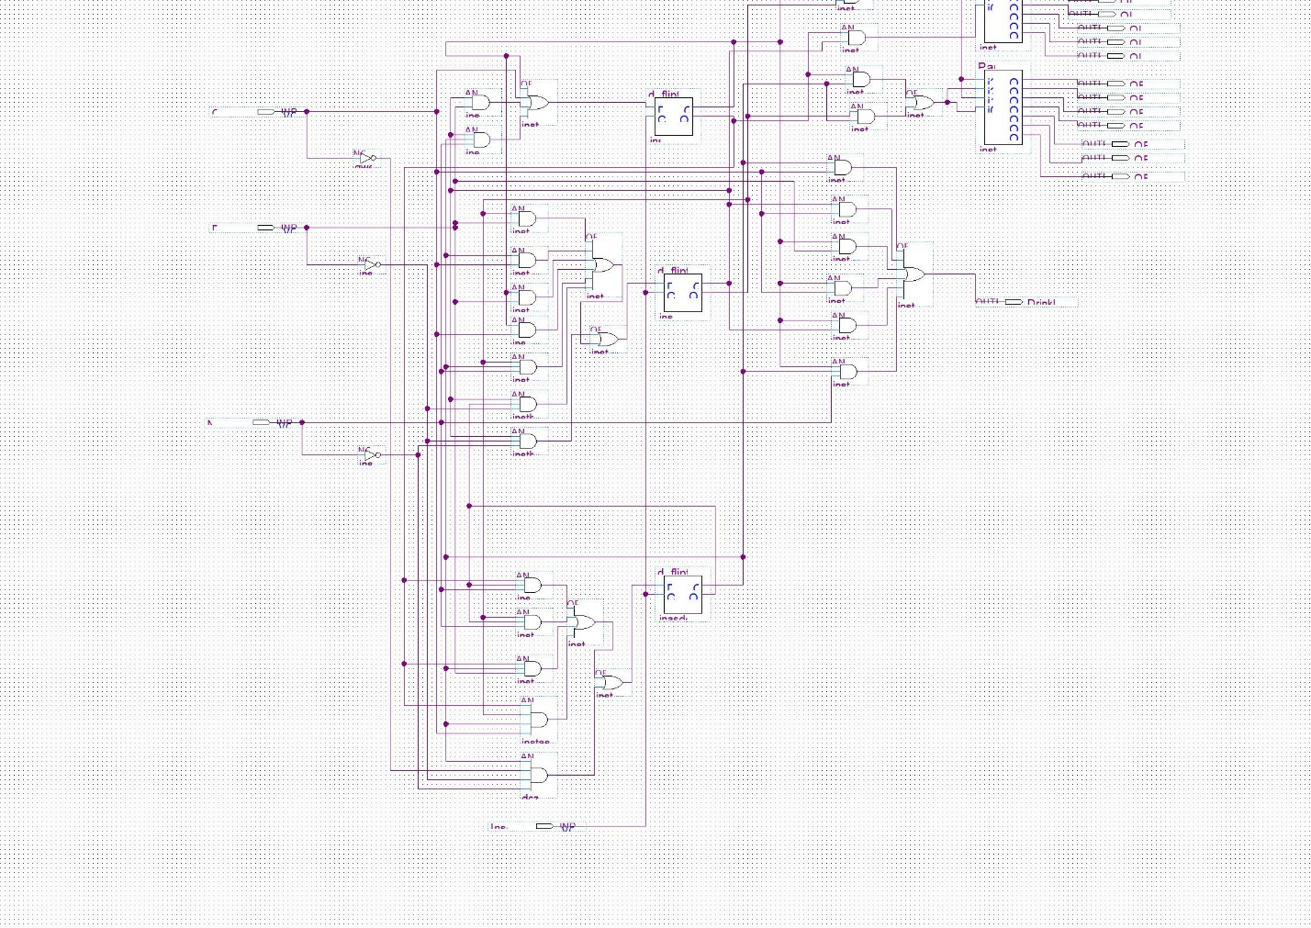

1. Results

The lab runs smoothly and correctly on the motherboard.

1. Discussion

Everything in the lab runs smoothly, we did the prelab and the implementation process to the board took a lot of time

1. Conclusion

I learned how to use state machine and flip flops to build a delayed result circuit.

1. Post-Lab Questions

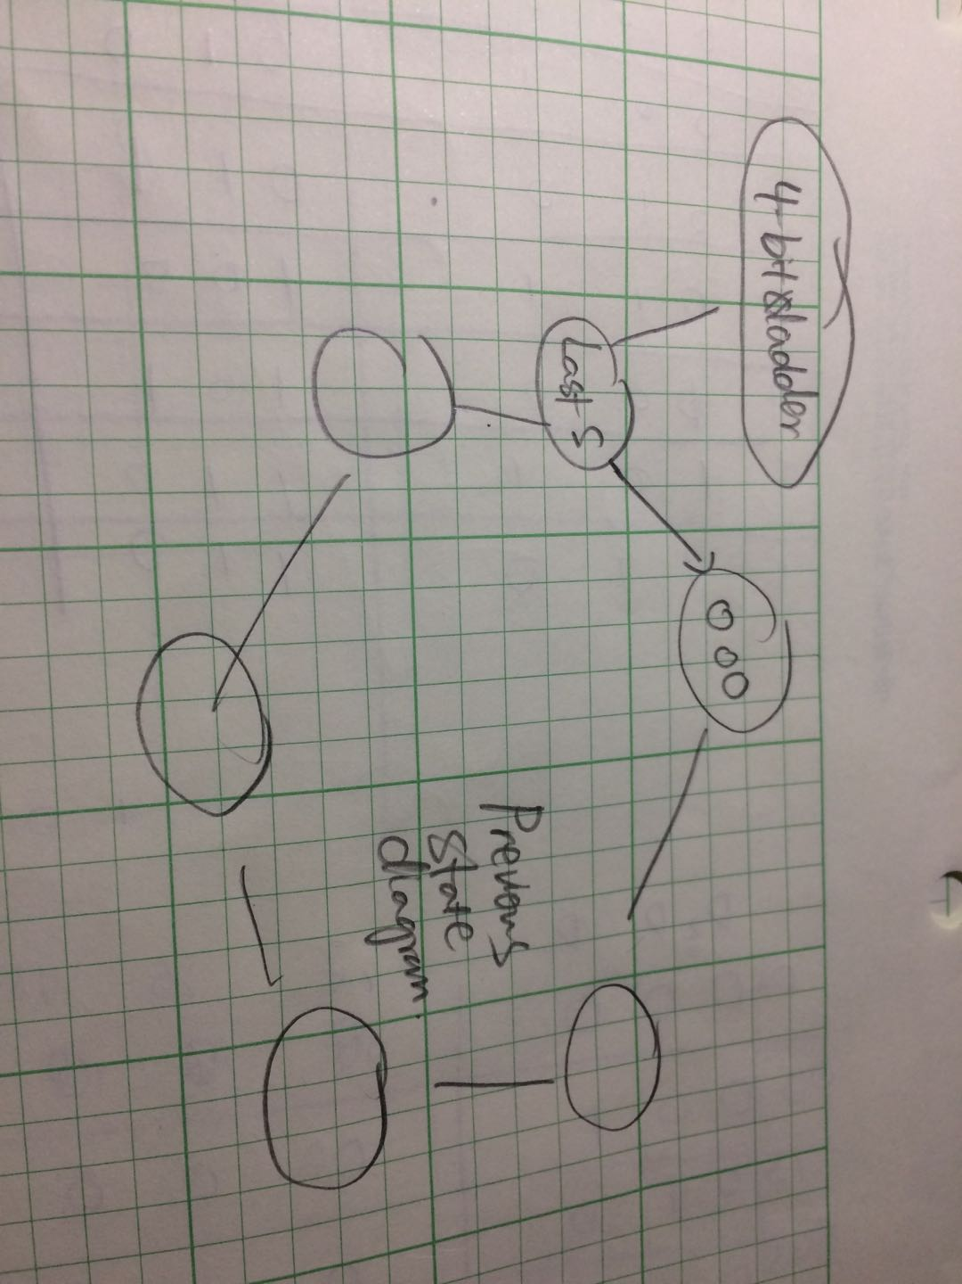

As in the photo, I would not change the previous state diagram, adding to it, I would add a 4-bit adder in the end to showcase the change.